Part 1:

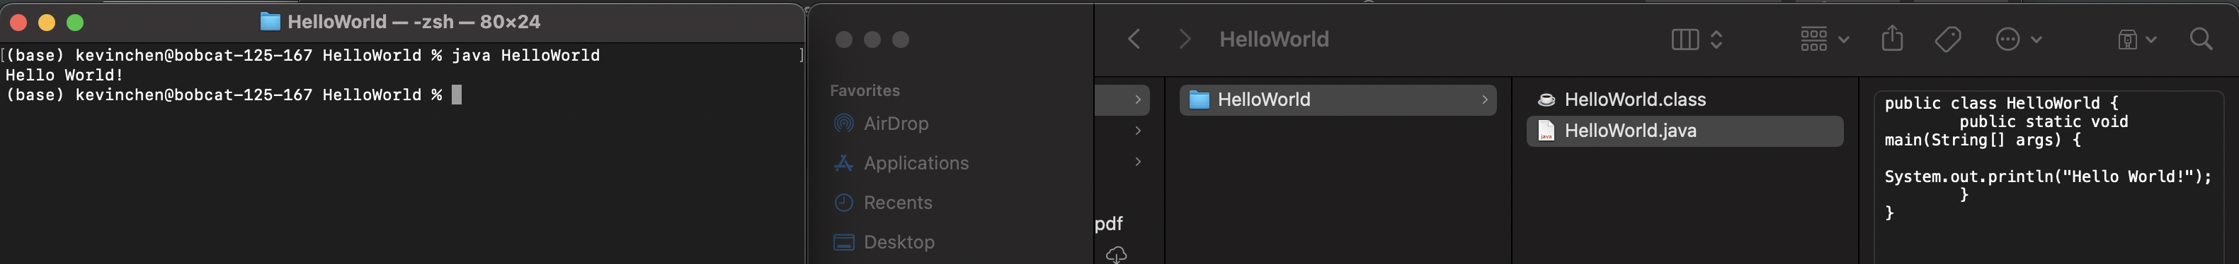

Part 2:

Part 3:

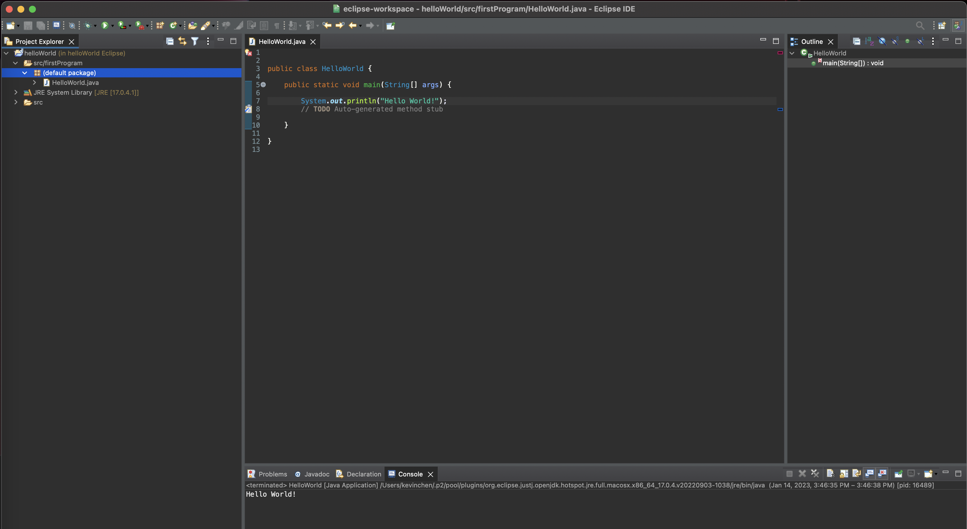

Part 4:

1. <https://www.w3schools.com/java/>
2. <https://exercism.org/tracks/java>
3. <https://www.codecademy.com/learn/learn-java>
4. <https://www.youtube.com/watch?v=xk4_1vDrzzo>

^(Bro Code on yt)